A human-centered summit and creative studio for 100 curated leaders across capital, media, technology, sports, policy, and the creative industries.

Singapore uniquely bridges two traditions: disruption tested through open debate, and long-term thinking strengthened by consensus.

AI on the Dot brings these perspectives together to explore how AI changes what we value, how we perform, and the stories we tell. This summit establishes Singapore as a premier human-centered AI hub, connecting global capital and technology with Asian creativity, community, and world-class live experiences.

Our Core Mission:
"How can AI expand human possibility without erasing the artist, the community, or the culture?"

When: October 6th, 2026
Where: Glass Dome, Singapore

Strategic Frame — Capital × Culture × Competition
The theme connects three communities already converging in Singapore that week, while keeping the conference firmly human-centered:
- Capital — what we value, who participates in the upside, and what responsible investment should reward.
- Culture — who authors the story, whose identity is represented, and how technology can strengthen rather than flatten community and craft.
- Competition — how people and teams use intelligent systems to make better decisions, adapt quickly, and perform under pressure.
These are not separate tracks but one set of questions: Who benefits? Who decides? Who is represented? Who is accountable? What becomes newly possible?

Intended Outcomes
- Build meaningful relationships across sectors that rarely work together.
- Identify practical, human-centered AI experiments leaders can take back to their organizations.
- Produce six memorable creative artifacts: one slide and one short trailer per Studio team.
- Give regional artists and creative technologists a visible role in shaping the conversation.
- Position Singapore as a connector of capital, culture, technology, and global performance.
- Create a first node for an ongoing Connecting the Dots network and follow-up pilots.

The Hourglass Structure: Shared Context to Focused Creation

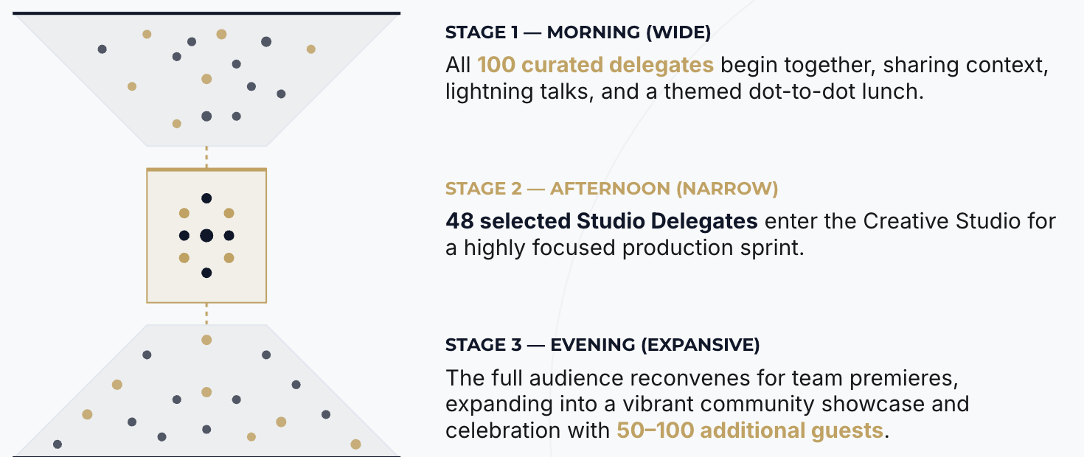

Prospective Breakout Sessions for Stage 2:

1 · The Creator Economy
How should capital support AI-enabled creativity while protecting authorship, livelihoods, attribution, and shared upside? Creative direction: a future in which artists participate in the value their work helps create.

2 · Trust Is the New Currency
What creates confidence in financial, media, and digital systems when synthetic content, impersonation, and automated persuasion are abundant? Creative direction: a practical trust principle, prototype, or organizational commitment.

3 · Human Judgment at Speed
How can AI help people and teams interpret complexity and perform under pressure without displacing leadership, intuition, or accountability? Creative direction: a story about the partnership between human judgment and real-time technology.

4 · The Future Fan
How can AI make sport and live entertainment more accessible, participatory, and culturally relevant without fragmenting the shared experience? Creative direction: a new fan experience rooted in connection rather than passive personalization.

5 · Identity, Avatar, and Rights
Who controls a person's face, voice, data, digital double, and cultural identity across entertainment, sport, and commerce? Creative direction: a clear rights framework or story that makes invisible risks tangible.

6 · Singapore: The Connected City
How can Singapore connect global capital and technology with Asian creativity, cultural context, community, and world-class live experience? Creative direction: a vision for Singapore as a trusted test bed for human-centered AI.

Invited Participants
- 1 Keynote
- 4 lightning talk speakers
- 1 moderator - panel discussion with the 4 lightning talk speakers.
- 6 facilitators
- 6 GenAI artists
- 48 Creator Track Participants

In the afternoon, delegates who are not participating in the Creative Studio will be invited to a “Learning Journey” to a local art gallery, IMBA.

